Strategic Product Placement Analysis:
An Interactive Tableau Dashboard for Retail CompanyBusiness Intelligence
Team ID:
Team Members: Miriyala Sai Likitha

PROJECT FINAL REPORT
Date: 13 July 2026

1. INTRODUCTION

1.1 Project Overview
This project aims to investigate the relationship between product positioning, sales performance, and consumer behaviour. Using Tableau, we will analyse data to uncover insights into how different positioning strategies impact sales and consumer preferences. By visualizing the data, we aim to provide actionable recommendations to optimize product positioning strategies and drive revenue growth.
A retail company wants to understand the impact of product positioning on its sales and consumer behaviour. They have collected data on sales figures, product placement, and consumer demographics. They seek insights into which product positioning strategies are most effective in driving sales and how they can tailor their marketing efforts accordingly. Through data visualization with Tableau, the company hopes to gain actionable insights to improve its product positioning strategies and increase revenue.
The project involves cleaning and validating the retail dataset, creating calculated fields such as Price Difference and moving averages, and developing interactive dashboards with filters and story points in Tableau. The insights generated help retailers identify optimal shelf positions, evaluate the effectiveness of promotions, understand the influence of seasonality and customer demographics, and make data-driven decisions that enhance sales performance and customer satisfaction. By transforming raw data into clear visual narratives, the project provides a practical decision-support tool for strategic retail planning.

1.2 Purpose
The purpose of this project is to analyze how product placement, pricing, promotions, and customer demographics influence sales performance and consumer behavior. By leveraging Tableau’s interactive visualization capabilities, the project aims to transform raw retail data into actionable insights that help retailers optimize product positioning strategies, improve marketing decisions, enhance customer satisfaction, and ultimately drive revenue growth.
The project aims to:
- To analyse the effect of product positioning on sales performance.
- To study how promotions, pricing, and seasonality influence consumer purchasing behavior.
- To identify the most effective product placement strategies for different product categories.
- To develop interactive Tableau dashboards that provide clear and actionable business insights.
- To recommend data-driven strategies that help retailers improve customer satisfaction and increase revenue.
In short, To analyze the impact of product placement, pricing, and promotions on sales performance and consumer behavior using Tableau. The project aims to provide actionable insights that help retailers optimize product positioning and increase revenue.
.

2. IDEATION PHASE

2.1 Problem Statement
Customer Problem Statement Template:
Create a problem statement to understand your customer's point of view. The Customer Problem Statement template helps you focus on what matters to create experiences people will love.
A well-articulated customer problem statement allows you and your team to find the ideal solution for the challenges your customers face. Throughout the process, you’ll also be able to empathize with your customers, which helps you better understand how they perceive your product or service.

Problem Statement (PS) | I am (Customer) | I’m trying to | But | Because | Which makes me feel
PS-1 | Retail company management | Identify the most effective product positioning strategies to increase sales and customer engagement. | Current product placement decisions are based on limited insights and inconsistent sales patterns. | Product placement, shelf visibility, and customer demographics significantly influence purchasing behavior. | Uncertain about how to optimize product positioning to maximize revenue and customer satisfaction.
PS-2 | Marketing and merchandising team | Understand consumer preferences across different product placements and store layouts. | Existing marketing efforts do not effectively target customer buying behavior. | There is insufficient analysis of sales performance and consumer response to various positioning strategies. | Unable to make data-driven marketing and merchandising decisions that improve business performance.

2.2 Empathy Map Canvas
Empathy Map Canvas:
An empathy map is a simple, easy-to-digest visual that captures knowledge about a user’s behaviours and attitudes.

It is a useful tool to helps teams better understand their users.
Creating an effective solution requires understanding the true problem and the person who is experiencing it. The exercise of creating the map helps participants consider things from the user’s perspective along with his or her goals and challenges.

Develop Shared Understanding and Empathy
SAYS | THINKS | DOES | FEELS
"I want to know which products generate the highest sales."  "I need better product placement strategies."  "Promotions should increase sales effectively."  "I need easy-to-understand sales reports." | "Which shelf position attracts more customers?"  "Are my promotions actually improving sales?"  "How can I increase revenue using data?"  "Which customer group contributes the most to sales? | Monitors sales reports and dashboards.  Compares product performance across categories.  Applies filters to analyze trends.  Makes decisions on product placement and promotions.. | Happy when sales increase.  Curious about customer buying behavior.  Concerned about low-performing products.  Confident when making data-driven decisions.
PAIN — Difficulty identifying the best product placement.. GAIN : Improved product placement decisions..

2.3 Brainstorming
Brainstorming provides a free and open environment that encourages everyone within a team to participate in the creative thinking process that leads to problem solving. Prioritizing volume over value, out-of-the-box ideas are welcome and built upon, and all participants are encouraged to collaborate, helping each other develop a rich amount of creative solutions.
This document applies the template to our project, Strategic Product Placement Analysis, which investigates the relationship between product positioning, sales performance, and consumer behavior. Using Tableau, the team analyzes retail sales, placement, and demographic data to uncover which positioning strategies drive revenue, and translates those findings into actionable recommendations for the retail company.
Reference: https://www.mural.co/templates/brainstorm-and-idea-prioritization

Step 1: Team Gathering, Collaboration and Select the Problem Statement

Context
A retail company has collected data on sales figures, product placement, and consumer demographics. It wants to understand which product positioning strategies are most effective at driving sales, and how marketing and merchandising efforts can be tailored accordingly. The team gathered to align on goals, review the available data, and frame the core problem before brainstorming solutions.

Problem Statement (How Might We)
How might we use data visualization and analytics in Tableau to identify the product positioning strategies that most effectively drive sales performance and align with consumer preferences, so the retail company can optimize shelf/placement decisions and increase revenue?

Key Rules of Brainstorming Followed
- Stay on topic
- Defer judgment
- Go for volume
- Encourage wild ideas
- Listen to others
- Be visual where possible

Step 2: Brainstorm, Idea Listing and Grouping
Every idea that could address the problem statement was written down without filtering, then similar ideas were clustered into themed groups.

Raw Brainstormed Ideas
■ Compare sales performance of eye-level vs. top/bottom shelf placements
■ Analyze the impact of end-cap and promotional displays on impulse purchases
■ Segment consumers by age, gender, and income to identify placement preferences
■ Build Tableau heat maps correlating store layout zones with sales density
■ Study the effect of checkout-aisle placement on add-on sales
■ Evaluate cross-category placement and complementary product bundling
■ Track seasonal/promotional placement shifts and their impact on sales
■ Analyze online marketplace placement (search ranking, sponsored slots) vs. sales
■ Correlate foot-traffic data with placement zones using Tableau dashboards
■ Survey consumers on visibility and ease-of-find as purchase drivers
■ Build a predictive model linking placement variables to revenue
■ Design an interactive Tableau dashboard so category managers can simulate placement changes

Grouped Idea Clusters
Cluster | Ideas Included
A. In-Store Placement  Strategies | Eye-level vs. shelf placement; end-cap & promo displays; checkout-aisle placement; cross-category bundling; seasonal placement shifts
B. Consumer Behavior &  Segmentation | Demographic segmentation (age/gender/income); visibility & ease-of-find survey
C. Data Visualization &  Analytics (Tableau) | Heat maps of store zones vs. sales; foot-traffic correlation dashboards; online marketplace placement analysis; predictive placement-to-revenue model; interactive manager dashboard

Step 3: Idea Prioritization
Ideas were plotted on an Importance vs. Feasibility grid so the team can agree on what to tackle first. Ideas in the top-right quadrant (high importance, high feasibility) are prioritized for the current project phase.
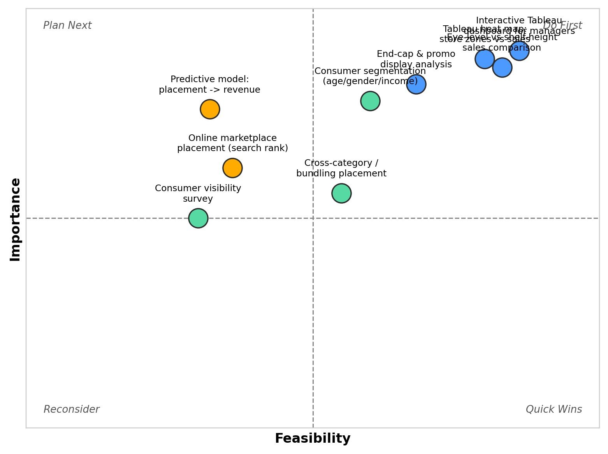

Prioritized Focus (Do First)
■ Interactive Tableau dashboard for category managers
■ Tableau heat map of store zones vs. sales
■ Eye-level vs. shelf-height sales comparison

Deferred / Lower Priority
■ Predictive placement-to-revenue model (high value but time/complexity constrained)
■ Online marketplace placement analysis (limited data access)
■ Consumer visibility survey (time-intensive relative to impact)

3. REQUIREMENT ANALYSIS

3.1 Solution Requirements
Following are the functional requirements of the proposed solution.
FR | Functional Requirement (Epic) | Sub Requirement (Story / Sub-Task)
FR-1 | Data Collection | Collect sales, product placement, and customer demographic data
FR-2 | Data Integration | Combine data from multiple sources into a unified format
FR-3 | Data Processing & Cleaning | Clean and transform raw data into structured format
FR-4 | Data Analysis (Tableau) | Analyze trends in sales and consumer behavior
FR-5 | Data Visualization | Create interactive dashboards and visual reports
FR-6 | Reporting & Insights | Generate reports and provide actionable recommendations
FR-7 | User Interaction | Enable users to filter, explore, and drill down into data

Non-functional Requirements:
Following are the non-functional requirements of the proposed solution.
NFR No. | Non-Functional Requirement | Description
NFR-1 | Usability | The system provides an intuitive and user-friendly interface.
NFR-2 | Security | The system ensures secure handling of sensitive data.
NFR-3 | Reliability | The system delivers accurate and consistent results.
NFR-4 | Performance | The system performs efficiently with minimal delay.
NFR-5 | Availability | The system is accessible whenever needed.
NFR-6 | Scalability | The system can handle growth in data and users.

3.3 Data Flow Diagram
Data Flow — Level 1 (Project Overview)
The DFD below describes how raw food ordering data flows through cleaning, transformation, visualization and finally to the end user via the Tableau dashboard.
# | Process | Description
1 | Data Source | Raw Food Ordering Behaviour CSV file downloaded from Kaggle.
2 | Data Cleaning | Nulls handled, duplicates removed, city / names standardized in Tableau Prep / Excel / Python.
3 | Data Transformation | Created calculated fields such as Price Difference (Price − Competitor Price) and applied filters to analyze product categories, promotions, seasonal products, and consumer demographics.
4 | Data Visualization | Connected the cleaned dataset to Tableau and created interactive charts including Sales by Product Position, Promotion Impact, Foot Traffic Analysis, Consumer Demographics, Product Category Analysis, Price vs Sales, and Competitor Price vs Sales.
5 | Dashboard & Story | Combined multiple worksheets into interactive dashboards and developed a Tableau Story to present the analysis step by step with meaningful business insights.
6 | User Interaction | Users can apply filters, explore dashboards, compare product performance, analyze sales trends, and derive insights to support strategic product placement and business decision-making.

3.4 Technology Stack
Technical Architecture
The build is deliberately lightweight: raw data is cleaned and transformed, then visualized in Tableau and published on Tableau Public so anyone can view it.
S.No | Component | Description | Technology
1 | Data Source | Product Positioning dataset (Excel/CSV) containing Product Position, Product Category, Price, Competitor Price, Promotion, Foot Traffic, Consumer Demographics, Seasonal Status, and Sales Volume. | Kaggle
2 | Data Cleaning | Checked data types, validated records, handled missing values (if any), ensured consistency, and prepared the dataset for visualization. | Excel, Tableau Prep
3 | Data Storage | Cleaned dataset and project files stored locally and maintained in a GitHub repository. | Local file system / GitHub
4 | Visualization Engine | Created interactive worksheets, dashboards, filters, calculated fields, and Tableau Story to analyze sales performance. | Tableau Public 2024.x
5 | Publishing | Published the interactive dashboard and story online for easy access and sharing. | Tableau Public Cloud
6 | Version Control | Managed project documentation, dataset, screenshots, and source files using GitHub. | Git & GitHub
7 | Documentation | Prepared project report, dashboard screenshots, story screenshots, and demo presentation. | MS Word / PDF / Google Drive

4. PROJECT DESIGN

4.1 Problem-Solution Fit
The Problem-Solution Fit Canvas ensures the proposed dashboard truly solves real problems faced by restaurant owners and food-tech analysts.
Block | Details
1. Customer Segment(s) | Retail store managers, supermarket owners, category managers, sales analysts, merchandising teams, and business decision-makers.
2. Jobs-to-be-Done /  Problems | Analyze product placement, identify high-performing product categories, compare competitor pricing, evaluate promotional effectiveness, and understand customer purchasing behavior to improve sales.
3. Triggers | Declining sales, ineffective product placement, poor promotional performance, increasing competitor pressure, and changing customer preferences.
4. Emotions Before / After | Before: Confused by large amounts of raw sales data and unable to identify business trends. After: Confident in making data-driven decisions using interactive dashboards and visual insights.
5. Available Solutions | Excel spreadsheets, manual sales reports, basic BI tools, and traditional reporting methods with limited interactivity.
6. Customer Constraints | Limited analytical skills, time-consuming manual reporting, budget constraints, and difficulty interpreting complex datasets.
7. Behaviour | Retail managers regularly review sales reports, compare product performance, monitor promotions, and make inventory decisions based on available data
8. Channels of Behaviour | Online: Tableau Public Dashboard, GitHub Repository. Offline: Business review meetings, printed sales reports, and management presentations
9. Problem Root Cause | Sales data is scattered across multiple fields and lacks meaningful visualization, making it difficult to identify sales patterns, customer preferences, and optimal product placement strategies.
10. Your Solution | Developed an interactive Tableau Dashboard and Story using the Product Positioning dataset, enabling users to analyze sales performance, promotions, competitor pricing, customer demographics, and product placement in one centralized, easy-to-understand platform.

4.2 Proposed Solution
S.No | Parameter | Description
1 | Problem Statement | Retail businesses struggle to analyze raw sales data and identify how product placement, pricing, promotions, and customer behavior influence sales performance and business growth.
2 | Idea / Solution | Develop an interactive Tableau Dashboard and Story using a Product Positioning dataset to visualize sales trends, product placement effectiveness, competitor pricing, promotions, and customer demographics for better decision-making.
3 | Novelty / Uniqueness | Combines multiple business insights—including product positioning, sales performance, competitor pricing, promotions, and customer demographics—into a single interactive Tableau Public dashboard and story that is easy to access and understand.
4 | Social Impact /  Customer Satisfaction | Helps retailers improve product availability, optimize promotions, enhance customer shopping experience, and increase customer satisfaction through data-driven decisions.
5 | Business Model / Revenue Model | Enables retailers to increase revenue by optimizing product placement, pricing strategies, promotional campaigns, and inventory management based on analytical insights.
6 | Scalability | The solution can be easily expanded by integrating additional stores, product categories, regions, time periods, or real-time sales data without significant changes to the dashboard architecture.

4.3 Solution Architecture
Five layers take the data from raw file to finished insight:
Layer | Responsibility | Technology
1. Source Layer | Raw dataset ingestion | Kaggle CSV / GitHub
2. Preparation Layer | Cleaning, standardization, calculated fields | Excel / Pandas / Tableau Prep
3. Storage Layer | Cleaned .csv / .hyper extract | Local / GitHub
4. Visualization Layer | KPI cards, charts, dashboard, story | Tableau Desktop / Public
5. Presentation Layer | Public shareable link | Tableau Public Cloud

5. PROJECT PLANNING & SCHEDULING

5.1 Project Planning
Product Backlog, Sprint Schedule and Estimation
Sprint | Functional Requirement | User Story / Task | Story Points | Priority | Team  Members
Sprint1 | Data  Collection | As an analyst, I can collect retail sales, product placement, pricing, and customer demographic data. | 2 | High | Likitha
Sprint1 | Data  Cleaning | As an analyst, I can import the Product Positioning dataset (Excel/CSV) into Tableau. | 5 | High | Likitha
Sprint1 | Calculated Fields | As an analyst, I can validate and prepare the dataset by checking data quality and creating calculated fields.. | 3 | High | Likitha
Sprint1 | Data Import | Connect cleaned dataset to Tableau Public. | 2 | Medium | Likitha
Sprint1 | Setup  Repository | Create GitHub repo with structure and README. | 2 | Medium | Likitha
Sprint2 | KPI Cards | Build 5 KPI cards | 5 | High | Likitha
Sprint2 | Charts | Used pie charts and bar charts etc.. | 5 | High | Likitha
Sprint2 | Dashboard | Assemble interactive dashboard with filters and tooltips. | 4 | High | Likitha
Sprint2 | Story & Publish | Create Tableau Story, publish workbook, prepare demo. | 6 | High | Likitha

Sprint Duration & Velocity
Sprint | Total Story Points | Duration | Start Date | End Date | Status
Sprint-1 | 14 | 6 Days | 20 Jun 2026 | 26 Jun 2026 | Completed
Sprint-2 | 20 | 8 Days | 27 Jun 2026 | 13Jul 2026 | Completed
Velocity Calculation:
Velocity = Total Story Points Completed / Number of Sprints
Total Story Points = 14 + 20 = 34
Number of Sprints = 2
Velocity = 34 / 2 = 17 Story Points per Sprint

6. FUNCTIONAL AND PERFORMANCE TESTING

6.1 Performance Testing
The dashboard was tested for functionality, correctness of KPIs, filter interactivity, load performance and cross-browser access on Tableau Public.
Test ID | Test Case | Expected Result | Actual Result | Status
T-01 | KPI cards display Total Orders,  Revenue, AOV, Avg.  Delivery, Avg. Rating | All 5 KPIs visible with correct values | All KPIs displayed correctly | Pass
T-02 | City filter | Charts update based on selected city | Charts updated as expected | Pass
T-03 | Cuisine filter | Charts update based on selected cuisine | Charts updated as expected | Pass
T-04 | Segment filter | Charts update based on selected restaurant segment | Charts updated as expected | Pass
T-05 | Tooltips | Tooltips show correct metric values on hover | Tooltips accurate | Pass
T-06 | Dashboard load time | < 5 seconds on Tableau Public | Loaded in ~3-4 seconds | Pass
T-07 | Story navigation | All story points navigable in order | Navigation works correctly | Pass
T-08 | Cross-browser | Works on Chrome, Edge and Firefox | Works on all tested browsers | Pass
T-09 | Mobile responsiveness | Dashboard viewable on tablet and phone | Viewable, layout adjusted | Pass
T-10 | Data accuracy vs source | KPI values match cleaned dataset totals | Values match source exactly | Pass

7. RESULTS

7.1 Output Screenshots
The following screenshots present the Sheets , the individual chart visualizations, and the final integrated dashboard built in Tableau Public.

Full Interactive Dashboard

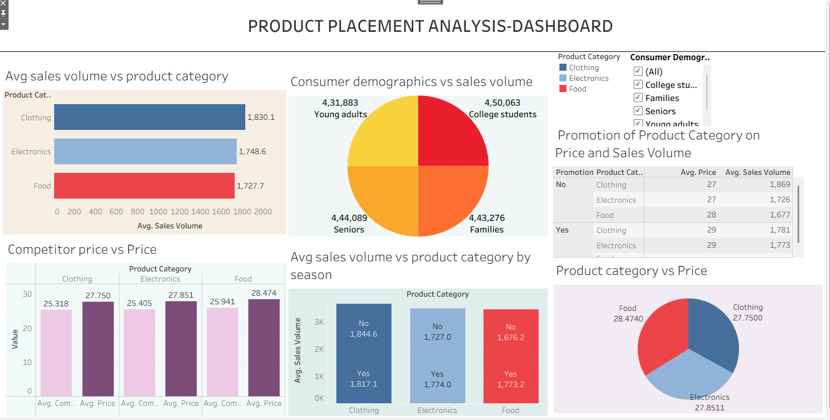

Figure 1 Product Placement Analytics Dashboard (Tableau Public)

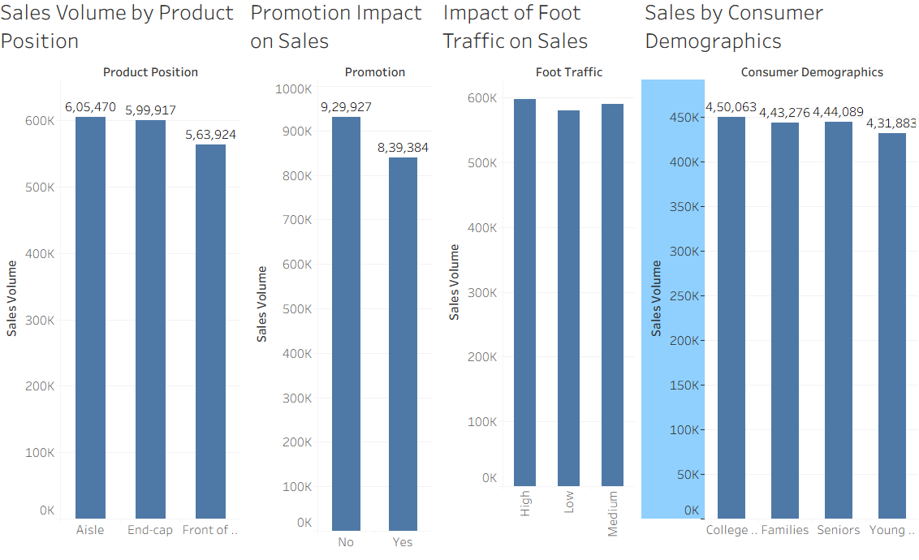
Figure2,3,4 : :Product Position, Promotion, Foot Traffic, Consumer Demographics

Page16
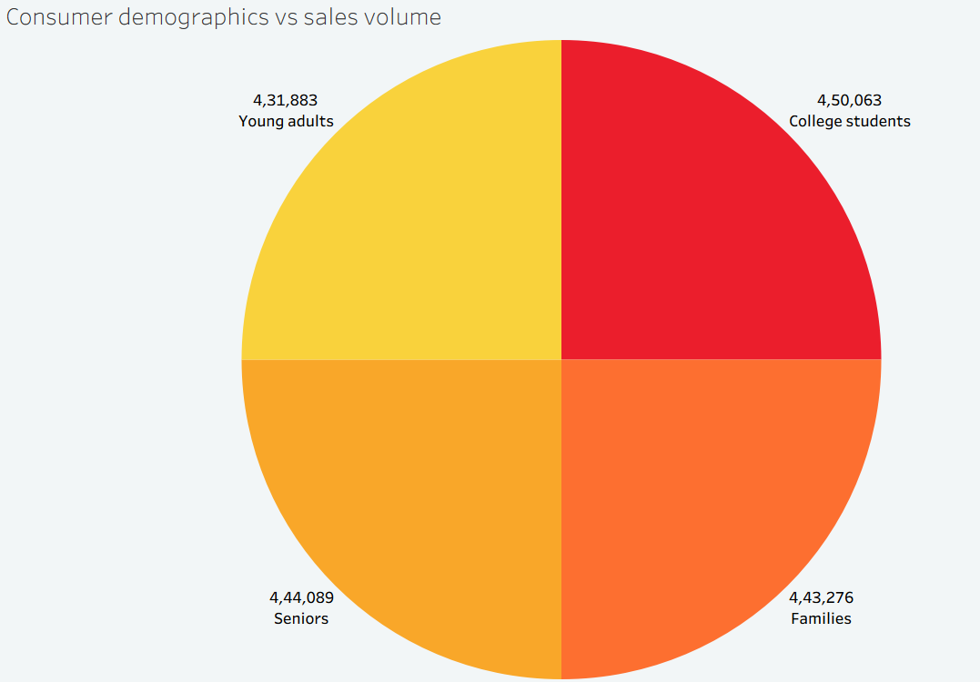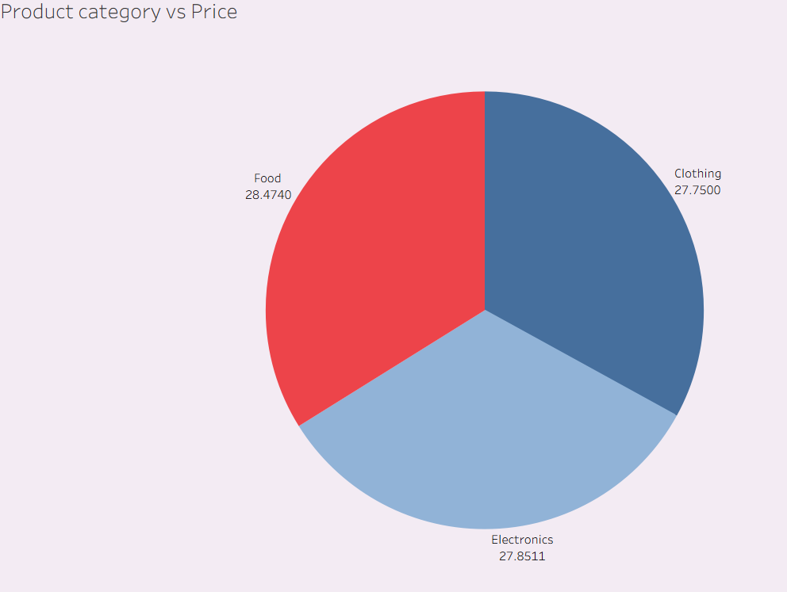

Figure5,6 : Average Sales

Page17

Behavioural Charts
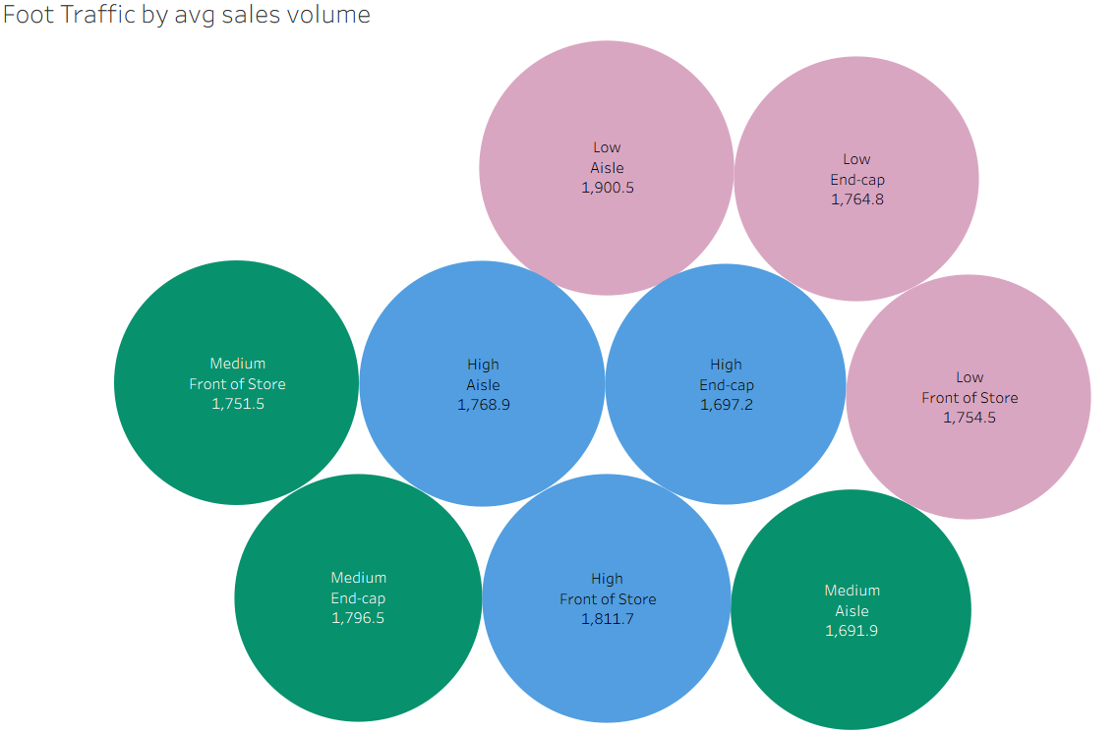
Figure 7 — Foot Traffic
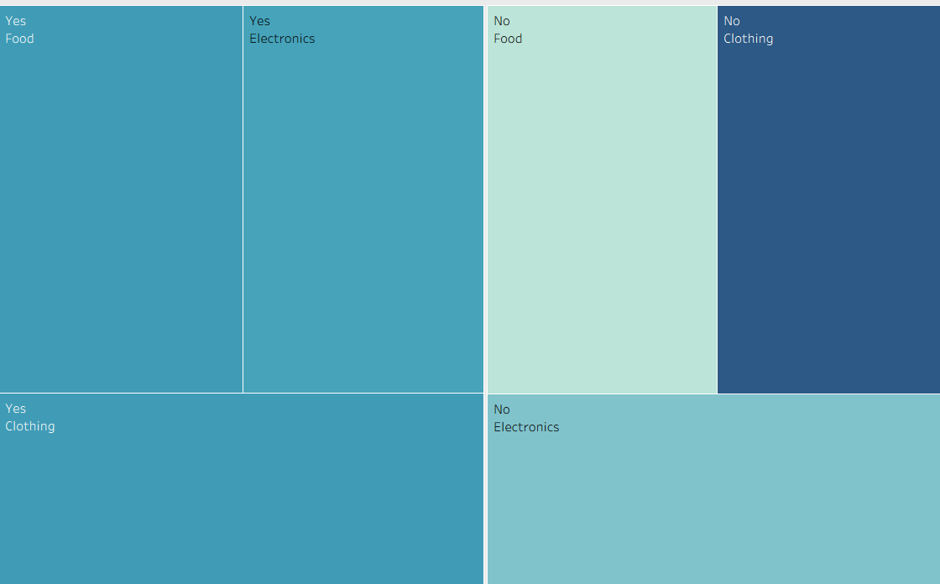
Figure 8 — Promotions

8. ADVANTAGES & DISADVANTAGES

Advantages
- Provides clear visualization of sales performance using interactive Tableau dashboards.
- Helps identify the most effective product placement strategies.
- Analyzes the impact of promotions on sales performance.
- Compares competitor pricing with product sales to support pricing decisions.
- Helps understand customer demographics and purchasing behavior.
- Enables faster, data-driven business decision-making.
- Interactive filters allow users to explore data from different perspectives.
- Easy to access and share through Tableau Public.
- Supports retailers in improving product positioning and increasing revenue.
- Reduces the time required to analyze large datasets manually.

Disadvantages
- The analysis depends on the quality and accuracy of the available dataset.
- Uses historical data and cannot predict future sales trends.
- Limited to the variables available in the dataset.
- Tableau Public requires an internet connection to access published dashboards.
- Sensitive business data cannot be securely stored on Tableau Public.
- The dashboard does not provide real-time data updates.
- Advanced analytics and predictive modeling are not included.

9. CONCLUSION
The Strategic Product Placement Analysis project successfully demonstrates how data visualization can support better business decision-making in the retail industry. By using Tableau, the project analyzes product placement, sales performance, promotional impact, customer demographics, foot traffic, and competitor pricing through interactive dashboards and stories.
The visualizations help identify sales trends, high-performing product categories, and the effectiveness of different product placement strategies. These insights enable retailers and business managers to make informed decisions that improve customer satisfaction, optimize marketing strategies, and increase overall sales performance.
Overall, this project highlights the importance of data-driven decision-making and shows how Tableau can transform raw retail data into meaningful business insights. The developed dashboard provides an efficient, user-friendly, and interactive solution for analyzing product performance and supporting strategic business growth.

10. FUTURE SCOPE
The Strategic Product Placement Analysis project can be further enhanced by incorporating advanced analytics and modern business intelligence features. Future improvements can make the dashboard more intelligent, scalable, and useful for retailers.
Integrate real-time sales data from retail stores for live dashboard updates.
Apply Machine Learning algorithms to predict future sales trends and customer demand.
Include inventory management analysis to optimize stock levels and reduce product shortages.
Expand the dashboard by integrating data from multiple stores, regions, or countries for comparative analysis.
Develop a mobile-friendly dashboard to enable managers to monitor business performance from anywhere.
Add AI-based recommendations for optimal product placement and promotional strategies.
Connect the dashboard with cloud platforms such as AWS, Microsoft Azure, or Google Cloud for improved scalability and secure data management.
Enhance the dashboard with real-time alerts and automated reports to support faster and more effective business decision-making.

11. APPENDIX

Source Code
All source files (Tableau workbook .twbx, cleaned dataset, screenshots, README) are maintained in the GitHub repository listed below.
Dataset Link
Product Placement Analysis Dataset — available in the https://github.com/SAILIKITHA2006/Strategic_Product_Placement_Analysis/blob/main/Product%20Positioning.csv

GitHub & Project Demo Link
GitHub Repository:
https://github.com/SAILIKITHA2006/Strategic_Product_Placement_Analysis

Tableau Public Profile:
https://public.tableau.com/app/profile/sai.likitha.miriyala/vizzes
Team Details: Team ID:
Team Members: MIRIYALA SAI LIKITHA
Domain: Data Analytics & Business Intelligence
Tool: Tableau Public 2026.x

